Understanding Cell Structure and Function
Use the link below to explore models of both plant and animal cells.
https://www.cellsalive.com/cells/cell_model_js.htm

Know the structure and function for the following:
Nucleus
Nucleolus
Cytosol
Centrosome
Centriole
Golgi
Lysosome
Peroxisome
Secretory Vesicle
Cell Membrane
Mitochondrion
Vacuole
Cell Wall
Chloroplast
Smooth Endoplasmic Reticulum
Rough Endoplasmic Reticulum
Ribosomes
Cytoskeleton

Label the cells below and give a brief description of each structure:

Cell Type: ______________________________
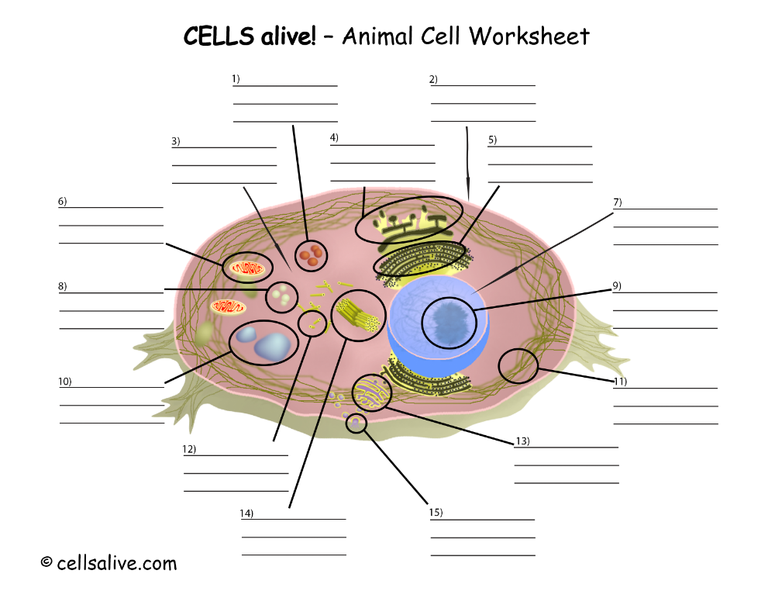

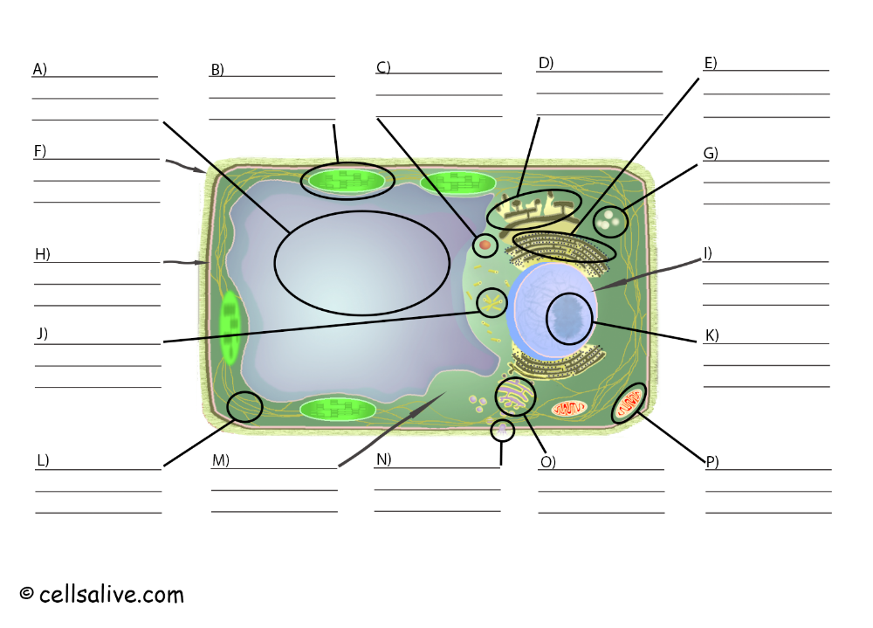
Cell Type: _________________________

